Initial output without input 9:

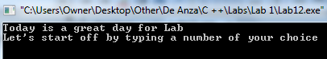

Output with input "9":

